**Prototype Design and Specification**

**Core game play**

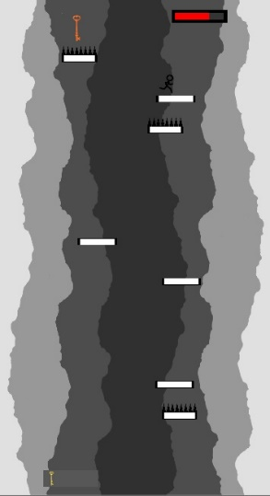**Rules**

This game is a single player game. The goal of the game is to collect keys, while avoiding hazards while jump down platforms(figure1). The player must not go past the viewport’s top and bottom boundary, or the game will be over. The player can jump to different platforms and stay alive within the viewport. The player will lose HP if in contact with the spike platform or get hit by a fireball. There are boundaries on the right and left side as well, restriction the player from entering. The boundaries are sound as white walls on the background.

**Objects**

**Platforms**

Figure 1

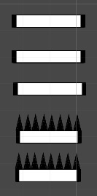The first object other than the player is platform. There are five types of platform in the game. The station platform, moving platform, spike platform, spike moving platform, and falling platform (figure 2). The platforms make up majority of the game and is the crucial part of the game. Platforms are randomly generated for each level, with a different spawning probability for each platform. Station platform is a place for player to stand on, before moving to the next platform. Moving platform is the moving version of the station one. Spike platforms will harm the player if he steps on it. Moving spike platform is the moving version of the spike one. While the falling platform will start falling once it contact the player, which will break when in contact to another other platforms.

Figure 2

**Keys**

Second object is key. In order to complete the level, the player must collect three keys for each level, before reaching the ending line. The number of keys collected will be shown on the bottom left of the screen(figure3).

**Hearts**

Figure 3

Third object is heart. The player will consume the heart and recover HP. There will be a health bar on top right to inform the player the remaining health(figure 4).

Figure 4

**Fireballs**

Fourth object is fireball. Fireballs will be raining from the top from level 3. There are two size of fireballs, with the huge one’s spawning chance is one in seven. There will be an explosion effect when the player is hit.

**Game flow**

The game encourages the player to complete the three levels, as there are no leader boards, or competitive features.

There is a difficult curve in game. While all the game objects are randomly generated, the level varies from easy, medium to hard. With the first level should be completed after a few tries, challenging on level two, and nearly impossible for level 3. The game relies on the player’s reaction time.

**Characters**

The player’s character is controlled by key A, key W and key D. The player can move right, left and jump. The character controls is simple, as it only requires keyboard, without the need of coordinating with the mouse. The player is given a movement speed at the start of each level, as well as jumping power. The jumping power and movement speed are related the camera moving speed. As the camera is constantly moving downwards. The character starts with no keys and 100HP. The number of keys collected by the player will be shown on the bottom left, while the amount of HP is shown on top right. When in contact with spike platforms, the player will take 30 damage. For fireballs, when the player contacts the fireballs, the small one deal 10 damage to the player, while the big one deal 25 damage to the player.

There is a key skill that the player needs for this game, the ability to jump mid-air. The character will have one jump available after leaving the platform, the jump will reset when touches another platform again. It is crucial to use the mid-air jumping skills to avoid fireballs, spikes, and to collect items.

**Physics and parameter**

Gravity is applied to the player and the falling platform. Gravity is crucial for this game. There are colliders for each object, making sure there will be proper interaction between objects. There is an slippery material applied to the platforms, setting friction to 0. Making sure that the player cannot stay on the edge of the platform.

**Level Requirements**

**Level relationship**

There are ten scenes in total, with three levels in the game. The game is started with a Main menu, with three options, play, tutorial, and quit. Clicking tutorial button will lead to a simple control tutorial, teaching the player basics of the game. Click play will advance to the next scene, introducing scene, giving player information about level one. After clicking continue in the introductory scene, level one will start. After completing level one, next scene will show, introducing level two, informing the player information about level 2. Clicking continue will lead to level 2. After level two, there will be a scene introducing level three, after clicking continue, level three will start. If the player complete level three, a victory scene will be introduced. If the player fails any of the levels, a game over scene will be shown, which will lead to the main menu.

**Target difficulty**

There are three levels in total, with easy, medium and hard level. In easy, the camera moves down in a reasonable speed, with a small number of spikes and falling platform generated. In level two, the camera will start to move faster, with more spikes and falling platforms generated. There will be a few small fireballs falling from above. The game is starting to become challenging in level two, because of the player need to concentrate on dodging fireballs as well as finding a safe platform to land on. In level three, large fireballs is introduced to the game, with four times more small fireballs. Fireballs raining from above will require the player to have good reaction speed, to both dodge the fireball while finding a safe platform at the same time.

**Feature Revelation**

Information about the game is available in the main menu, clicking the tutorial button. The tutorial will teach player the basics of the game. Information for each level is revealed before the level start, with an introduction scene before each one. The hazards and objectives will be introduced to the player before the level start. There are items available for the player, where they are all introduced when level one started.

**Any third-party assets used, and inspiration will be credited and referenced in a readme with the game submitted.**

**The coursework is done with Unity version 2018.3.5f1.**

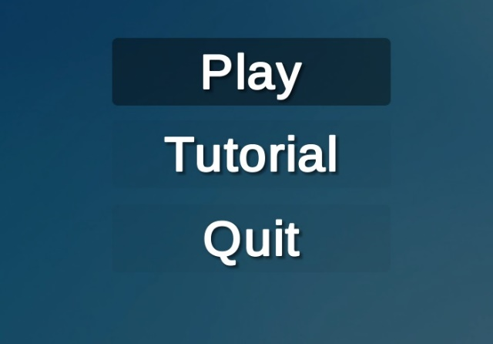**Prototype Instructions**

Tutorial:

1. Click play in the main menu (figure 5)
2. Click continue in the first intro
3. 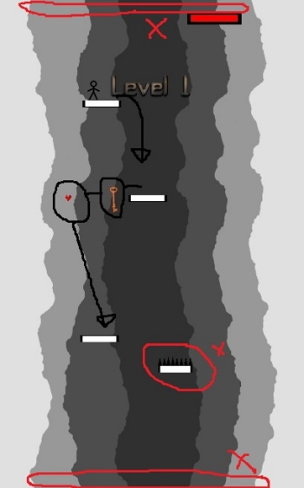When the level start, player will be spawning near the top of the screen. The player will have to run to the edge of the platform and jump down to the next safe platform. The player should follow the path shown on the right. The player should jump down to the next platform while collection keys for the level (black arrows in Figure 7).

Figure 5

1. The player should avoid spikes and try not to fall out of the viewport (Circled in red in figure 7).
2. 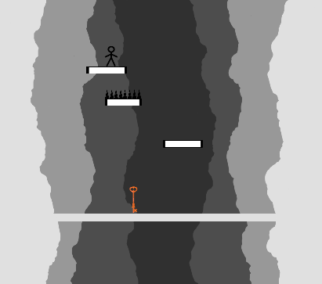After collection three keys, when the player contacts the white line at the end of the level, he will advance to the next level’s introduction scene. The line is shown on the figure on the left (figure 6).
3. If the player is low on HP, the player should try to collect hearts to recover.

Figure 6

1. 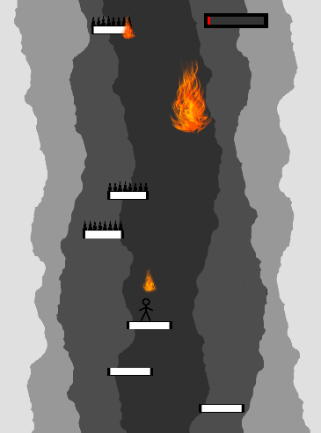In level two and three, fireballs will be introduced, as shown on the figure on the left. The player will need to try to avoid contacting the fireballs. (figure 8).

Figure 7

1. The game will end when the player completes all three levels and will give the player an option to return to the main menu.

Figure 8